God Uses the Worst to Bring out the Best
November 29, 2016
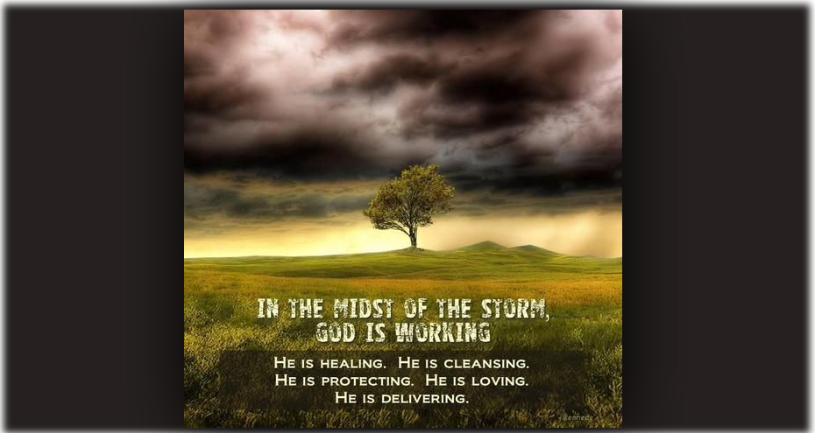
May the peace and forgiveness of God reign in our hearts. I say that, Heartdwellers, because I certainly need that forgiveness to reign in my heart.

The Lord permitted a very dear and sincere Christian to show up on our doorstep - uninvited, seeking counsel. But the enemy, being a wicked opportunist, knows how to manipulate and use even the best of us to cause problems.

Looking back on my Christian life to times when I was a single mom with four children, and even after Ezekiel and I were married and were traveling as missionaries. I can remember times that we showed up at monasteries or different places like that and caused an awful lot of disorder, just by our presence. 'Cause it was out of the ordinary. So, this is something that can happen to all of us. I look back now and think to myself, how they were really patient with us. They set aside what they were doing to meet our needs. And in some cases, it really interrupted their ministry. Amazing charity and patience.

As a matter of course, we don't answer the door when people show up uninvited - unless the Lord puts His finger on something and asks us to do that. Which in this case - He did. So we couldn't wiggle out of it.

I knew this was going to be a trial, a test and an offering - a suffering for Donald Trump and that whole situation with our nation. And it lasted two months, and only now is coming to a conclusion.

I felt it the day it showed up and I fought against my flesh every day to love and bless, which was a mighty struggle. Especially because I was interrupted in giving you messages, and our prayer routine and everything else was turned pretty much upside down. So, if you wondered why there was a little lapse a couple of times in the last couple of months, now you'll understand why. We were really in the crucible with this challenge.

Not wanting to offend Charity, and do what we could, where we could - but also being faithful to the ministry the Lord has already established with us. I'll tell you - it was a hard fight, and the aftermath - wow. A lot of seeds that I have to deal with.

But I also wanted to say that we learned a great deal. And you may have noticed the tones of the messages, that there was obviously some encouragement there, for people who are being called to give their everything to the Lord. And this is how we work. Life situations come and work themselves out, and in the process of that, we learn new things. When we learn, we share it with you. So, that has been the tone of the messages for the last few weeks. And I know that there are many of you going through the same challenges right now, 'cause you've been writing to me and telling me. So, Holy Spirit works across a broad audience. These same messages that were given for this situation, particularly, also applied to you. It's amazing how He works that way.

So, we learned a great deal as well.

Really I thought we had maybe helped this soul, but then the thorns started coming, the accusations, the attacks and ingratitude.

You see, when you do your best for a soul and give them your very best time and discernment, if they don’t want to hear it they turn and attack you and make you the villain. In other words, you aren’t hearing from the Lord…"because I won’t do what He is asking of me." One day the soul gets copious confirmations while others fast and sacrifice for him. Another day they weren’t confirmations at all and you’re a false prophet or at the least - deceived.

May I tell you the rule of discernment we have always operated by? Is that when you feel God calling you to something and your heart is inflamed with a desire to love Him more, to give Him more, you seek confirmations in prayer and fasting. It’s best to keep a journal, either on your computer or hand-written. Then when you strike out on your journey in obedience to the Lord and you encounter every manner of opposition, you go back to your original discernment and hold fast to that. You don’t change in midstream.

God hasn’t changed His mind, and no one who puts their hand to the plow and turns back is worthy of the Kingdom. So DON’T TURN BACK.

The waters are getting rough, because Satan wants to take you down before you reach your destination. He hates you, you are a threat to his kingdom of darkness and he will throw up every barrier and discouragement to stop you. His major venue of attack will be Doubt. The Lord told me, “To every work of God there are assigned demons of Doubt, Fear and Scrutiny by the enemy.”

We Christians are most vulnerable in discernment, because we Love God and want to do His will. So the enemy will try to convince us that what we are doing is NOT His will, that we didn't discern properly - and that’s why we have so much opposition.

LIES! LIES! LIES!!!!!

And if the character of the soul is weak and they didn’t get proper confirmations before they undertook their work, and if there is any part of them that is not totally surrendered, this tactic of the enemy will work almost every time. And if God sends good prophets and servants to help the soul on their way by confirming those directions, the soul will turn against them and start to concoct all kinds of falsehoods to discredit them.

This soul I am talking about gave away everything they had, and they were well off and secure. They gave it away and then set out in their pickup to serve the Lord. That’s how far they got with their commitment. But when the direction God gave and confirmed to them firsthand didn’t seem doable to them, they turned around and went their own way. Now it is time for someone else to step in for the Lord to assist them; we are no longer of any use. The tragedy of this is, this soul had gone from community to community getting the best of counsel from many well-known and seasoned prophets and still chose their own way. So, we weren't the first.

Now in this message the Lord explains why He allowed this. It brought tremendous loss and suffering to our household and even to the channel when we had issues on our doorstep we never invited, that were distracting us.

But here is what the Lord had to say about this trial.

Jesus began, “It is always the ones who cause the most trouble who are doing you the most good. Man thinks, 'interruptions, loss of time, emotional pain, ingratitude, betrayal.' I think, 'My Bride you are beautiful, you are looking more like Me all the time.'

"You see, I am the one who chooses these vessels who sow disorder into the lives of others. Though the enemy uses them to cause loss of time and ministry, I use them to build character and charity.

"I told you from the beginning, this is your suffering. You saw it coming, I told you what it was. But I confirmed to you that I wanted you to deal with it and not turn it away.

"But in the heat of disappointment, confusion and betrayal, you lost sight of what I was doing: that something I was doing in you and Ezekiel. Yes, the offerings are powerful because of the deep pain they cause, but things are shifting in you. You asked to be compassionate and gentle, and so I sent you tests. Now you are bitter and complaining of what was lost in this trial? You are angry, resentful and disgusted?

"Do you know how many times I could have felt that way about you, but I didn’t. Do you know how many times you let Me down, Clare? And why are you upset about what was lost, the sickness it caused, the pain the distraction? These were sent to temper your nature and cauterize your flesh.

"You should be thanking Me, not holding anger, which brings seeds of resentment and gives the enemy an opportunity to build a stronghold. Which, by the way, will crush every grace I've given you, if you allow it to continue. This is why I want you to thank Me for what I did through this vessel and look closely at areas that you resemble them.

"This is all for humility, My Love. I am not chastising you, I am teaching you. Thank Me for all the pain this has caused and forgive. Nothing is lost, Clare. So much is gained by shouldering this cross. But if you hold a bitter seed in your heart, it will spread and choke out the good life. So you must forgive and relinquish that anger, lay it down at the Cross, with all the other bitter crowns I wore, and you've worn. Yes, lay it beside My Crown of Scorns.

And tongue-in-cheek, He quipped, "Just think how lucky you are! If you had put an ad in the paper for someone to do all these things to you, you couldn’t have hired a one!

"Really, this situation was My gift to you. Turn it into a blessing, because the enemy will turn it into a cursing if you don’t. And I am not threatening you, My Beautiful Bride. I am merely stating a fact. You mustn’t hold anger and unforgiveness in your heart. You must relinquish it and allow Me to clean it out.

"My people, I have sent you all many such ‘gifts.’ Now you know how you are to handle them. With the holidays coming up, there will be outstanding opportunities to forgive and lay that crown of scorns beside My own at the foot of the Cross.

"I am ripening the fruit on your vine. I am turning bitter grapes to sweet. I am harvesting grapes and putting them in My winepress. It is in the crushing of the grapes that the flavor is obtained. It is in the patient waiting through trials that the vintage ripens into a fine wine, worthy of the King’s table.

"Yes, My vineyard, I am ripening you. Some I am harvesting and the wines are superlative. The grapes have survived the little foxes and ripened in the sun of My glory and worship. They have come to fulness of age through the storms that have swept the hillsides. And I am well pleased with those of you who know how to turn a curse into a blessing.

"Indeed, this is My work; what Satan curses, I bless and good comes forth from it. You are learning the fine arts of grace and how to flow with it. There is nothing the enemy can do to any of you that you cannot derive good from. I see to it. I want you to be examples and teach this principle to those around you.

"Many of you have begun new endeavors for Me: music, art, books and teachings. These are wonderful - and greatly threatening to the enemy, by the way. And so there will be assignments against you to rob you of your creative joy. The more impact your anointing will have, the more you will be attacked.

"You can rest assured, you will be attacked. But I am teaching you how to turn that attack into long-suffering and character forming grace - which will give forth the sweet odor of sanctity to your God.

"So rest assured, these trials are for your good and increasing your richness in mercy and grace.

"Go now, forgive, give and move on. Do not get bogged down. Once these lessons are learned, move forward. There is a time to let go. Pray and let go, allow Me to resume My work in these souls who seem to hinder all that is good."

And I just want to add to this, dear ones, that I know I've got some seeds in there, seeds of anger and resentment. So, I am going to go before the Lord and really ask Him to help me to repent on a deep level, that these things can be cleaned out. Because we don't want these in our hearts, and they do cause tremendous problems. The longer they linger, the worse it gets.

So, if you've got any bitter seeds from situations that God has allowed in your life, be sure to repent of those seeds and ask Him to clean your heart out. With the seeds, come demons, doors, defecation from the demons. And they leave a mess, they leave a slimy mess in your heart. If you doubt what I'm saying, you ought to read Rick Joyner's dreams about what the demons do to Christians, and what they say and how they say it - and what they leave behind.

So, you don't want that working in your soul. And it goes into your whole body, unfortunately - it actually effects your physical health.

So please - if you have any seeds in your heart, give them up to the Lord and ask Holy Spirit to show you. Allow Him to clean these things from within you.

And thank you so much for your continued support and your beautiful comments. We really appreciate them! They give us a lot of strength and hope. God bless you all.

